Let this be our prayer to Jesus in 2024:
“My heart is ravished with delight when I think upon thee- the bright resemblance of thy face so fills this heart of mine.” Auld Lang Syne

Dear friends in Christ,

January 9th already! It’s still early in the New Year so not too late to wish you a very Happy 2024 and everything that awaits us. May there be exciting opportunities and possibilities to encounter in our faith communities as we do the gathering work of Christ whose newness of life is overflowing in our hearts, homes, and communities. No doubt there will be one or two daunting challenges for us to face. But we need not be afraid of them or paralyzed by them because we walk into this year with a faithful and trustworthy God.

Colin and I were delighted, after a four-year hiatus due to cancer and covid, to open the doors of Bishophurst on January 1st for the traditional New Year’s Day levee. Old friends and neighbours and newcomers who’d never visited our diocesan home enjoyed one another’s company as we rang in the New Year. Bishop Sullivan’s cannon ceremonially blasted across the lawn – a green one at that!

One of our guests mentioned that she was 15 the last time she was in Bishophurst - 75 years ago when Archbishop Wright was the Bishop of Algoma. She was a member of the Cathedral GA singing group who were invited to entertain the guests. And yes, she did notice a great change in the interior of the house.

The women from Emmaus Anglican Church were gracious in preparing the refreshments for the Levee and arranging ‘pourers’ to serve the tea and coffee from the very best silver tea service we have on hand. Thank you!

At one point during the festivities, Colin played the much-loved song, ‘Auld Lang Syne’ which certainly fit the occasion. Composed by the Scottish poet, Robert Burns, in 1788 it speaks of the passing of time. What was, now gives way to what will be. There was emotion and sentiment and even a bit of melancholy in our singing as we remembered all that happened in 2023 along with the people who made it so, as now we turn our gaze to the coming year.

As I was searching for a printable version of the song, I came across a modern version of Auld Lang Syne. The second verse caught my attention.

My heart is ravished with delight, when thee I think upon; all grief and sorrow takes the flight, and speedily is gone; the bright resemblance of thy face, so fills this heart of mine; that force nor fate can me displease, for the sake of days gone by.

What if, instead of this being just another New Year, the words of this verse could become our prayer to Jesus Christ - the Word made flesh? “My heart is ravished with delight when I think upon thee- the bright resemblance of thy face so fills this heart of mine.”

Liturgically and theologically, we have celebrated the Incarnation of Emmanuel, “God with us” at Christmas. This past Sunday we commemorated the Baptism of Jesus as we enter the beautiful season after Epiphany. Epiphany means ‘manifestation’ and bears witness to Jesus’s unfolding identity as the Son of God - first to the Magi and eventually to the whole world.

In the account of Jesus’s baptism from Mark’s gospel, the heavens split open announcing the cosmic significance of what has just happened. The voice from heaven affirms Jesus as the beloved Son of God. The dove is a reminder of the hovering Spirit at creation bringing order out of chaos. The entire story, which will follow, is the story of Jesus and of what God did through him. The beloved Son of God will reorder the cosmos and herald a new kin-dom and a new way of being where everyone belongs regardless of race, class, or social status. Where mercy and forgiveness are spoken in acts of kindness and love. Where there is peace in our homes, in our communities, and among the nations of the world.
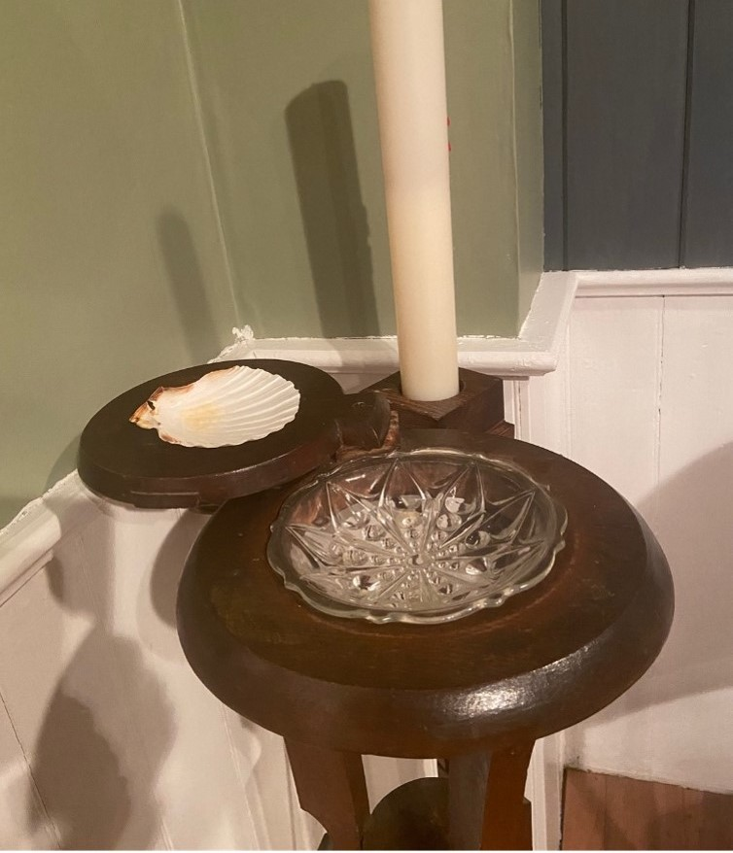
Remember your baptism and be glad.
The font from St. George’s Falkenburg in the Bishophurst Chapel with water from the Jordan River in it.

Our baptism establishes our identity. Jesus is who God says he is, and we are who God says we are. Through baptism we are also beloved of God. “For as many of you as were baptized into Christ have put on Christ.” (Gal. 3:26-27) This identity established at our baptism is only a word until it comes to life in convincing power in the unfolding story of our lives in Christ. But this means that we must daily live our baptism, responding to God’s gracious gift of new beginnings and possibilities in our lives. Every day we must open ourselves up to God’s Holy Spirit saying yes in all the big and little things we do and seeing God-with-us in the faces of the people we meet. If we can do this, we will find that God comes to us, renewing in us what God began in our Baptism. Emmanuel comes to us so that we can come to God.

I can say for a fact that there are days where this is easy for me and days when it is difficult and challenging. Some days the Spirit’s work in me seems vivid and meaningful; some days it is not. Some days I respond with joy and hope to the Spirit’s leading and some days I want to hide from it. But I know that nothing about my baptism and life in Christ is about my feelings but about the truth that the Spirit’s presence is within me regardless of how I might be feeling on any given day and has been since before I was born. Every day, the God who named you and me, claimed you and me, and gifted you and me in baptism, claims us again – but this is all the Spirit’s work.

In this New Year, my prayer is that God’s Spirit will blow fresh new winds in our lives and make us co-creators with God - refreshing us when we are weary, soothing us when we are hurting, comforting us when we are sad, disrupting us when we are too comfortable and prodding us ever onwards to do new things in God’s name, pouring out God’s love upon us until we are all remade in God’s image and likeness.

With love and affection,
+Anne

