Resolutions:

Resolutions come to Synod from three sources:
- From the Executive Committee and other Committees
- From Deanery Councils
- From Synod delegates.
Priority has, generally, been given to resolutions in this order. Priority is also given to resolutions included in the Convening Circular.

Notices of Motion are submitted to the Resolutions Committee which recommends improvements in wording and structure to the movers, or may choose to combine a number of motions on the same subject into a single motion. They are then passed to the Agenda Committee which assigns it a priority and timing on the Agenda. The Agenda Committee establishes a date and time (usually the second day of Synod) after which no further Notices of Motion will be accepted. The Chair may choose to waive this requirement for matters in urgence, but this has very rarely been done.

It has been our recent practice to allow the movers of Motions to include a brief explanation of its intent. This is termed Background. It should explain the reason for bringing the Motion forward, but must not argue the merits of the question which is properly done only on the floor of the Synod.

Taking the Fear out of Resolutions or How to write a Motion (also known as a resolution)

When I first attended synod, I was way too scared to even try to write a resolution. However, I was more scared to speak and I would have greatly appreciated the opportunity to practise writing a motion.

The goal of the Resolutions Committee is to take the fear out of Resolutions.

I have developed a little primer which is included below. Please take this primer to your spring Deanery Council Meeting as an agenda item. Our hope is that all Deanery Council members will find this information helpful.

Many people who attend Synod are familiar with a traditional way of writing resolutions which is formal and includes long statements. Traditional resolutions include a section called Whereas. The resolution itself begins with the phrase Be it resolved.

Our approach is less formal. We use the term Background in place of the Whereas statements and we begin the resolution with a simple That and leave out the Be it resolved that.

Resolution Primer:

Please ask for 40 - 45 minutes on your Spring 2023 Deanery Council Agenda.

This session could be led by:
- An incumbent or
- A Lay Delegate

The Beginning (15 min)

- Read out loud the following passage of scripture.

The wisdom from above is first pure, then peaceable, gentle, willing to yield, full of mercy and good fruits, without a trace of partiality or hypocrisy.
James 3:17

Ask people to turn to a person seated beside them and ask what the above passage means in terms of decision making. What type of decision-making should we be doing in Algoma? What can we learn from this New Testament passage?

Ask a few people to share their reflections with the whole group.

- Review the format of a resolution and background.

Here is an example from a June 2014 Executive Committee Meeting.

Background
Jane Mesich outlined the request from the National Church to utilize our Algoma Anglican mailing list to support the Gifts for Mission Appeal.

Resolution
That the Synod Office be given permission to share the Diocesan mailing list with the National Church’s Resources for Mission for the purpose of their Gifts for Mission appeal, providing that the list is not shared with any entity not directly related to the appeal.

Here is another example from a March 2012 Executive Committee Meeting.

Background
Ed Swayze, Regional Dean, outlined the proposal received from St. Michael and All Angels Thunder Bay regarding the installation of a lift for accessibility. The Deanery Officials are supportive of this project. The parish has funds on hand as a result of the sale of two properties.

Resolution
That the Executive Committee authorize the parish officials at St. Michael and All Angels Church, Thunder Bay, to install a passenger lift with the cost not to exceed $90,000 subsequent to obtaining additional insurance and a service contract for the lift.

The Scenario (10 min)

- Please encourage each person to read the following scenario.

You are at synod and you feel a strong desire for the church to focus on a social justice issue. You have read about Mercy Ships bringing health and healing to Africa.

Here is the article that caught your attention.

“Hospital on water” reaches thousands with life-changing surgeries

By STEVEN SUKKAU | January 20, 2015

This past November, the Africa Mercy lay docked in Madagascar. Those aboard were expecting about 200 people, many of them living in desperate poverty, to show up for the free surgeries provided by the ship’s medical staff. A crowd of nearly 3,000 came instead.

Canadian Joanne Thibault volunteers with Africa Mercy, part of a crew of 450 volunteers from 35 different nations from diverse backgrounds. Some have medical expertise, while others like Thibault are part of the support crew that keep the ship running.

“Think of Africa Mercy as a small town,” Mercy Ships director Tim Maloney explains. The ship needs the same sort of experts, from carpenters and plumbers, to teachers who run the small school and cooks who serve hundreds of meals a day. Everyone from the captain of the ship, to the hundreds of volunteer doctors pay their room and board to serve on Africa Mercy.

“Our mission is to be the face of God’s love in action,” Thibault says. And Mercy Ships, an organization run out of Victoria B.C, truly does transform lives, she adds, both medically through surgeries that heal disfigurements, cleft pallets, tumours, and more as well as spiritual healing.

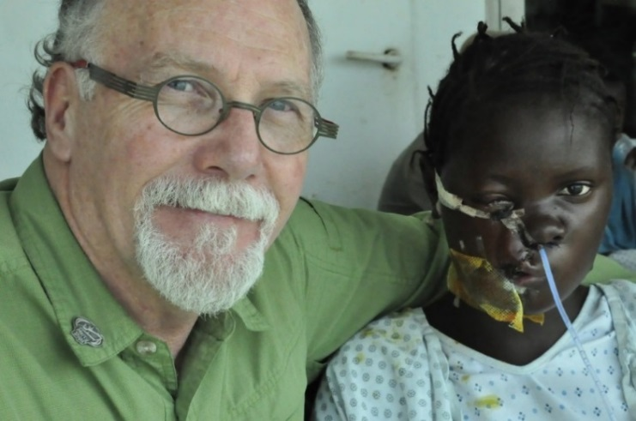

Mercy Ships director Tim Maloney with one of the many patients helped by their volunteer medical staff.

The international faith-based charity deploys hospital ships and land-based teams, providing primary medical care to some of the most impoverished people on Earth, for free. Founded in 1978 Mercy Ships has to date worked in 57 countries providing services in excess of $1 billion to more than 2.4 million people.

“It’s a unique experience for patients, they are given a whole lot of love, are fed and nurtured,” Thibault explains.

She recalls the story of a man living in isolation from his community. A larger goiter left untreated for 20 years had made him a pariah, but after a 20-minute surgery, he was cured and returned to his family and neighbours, given his life back.

“I am a stranger, and you welcome me, I don’t know you and you heal me, why are you doing this?” he asked.

“We’re here from Jesus to bring His love,” is the answer from those on board Africa Mercy, and for a man who has been Muslim all his life the event starts a new beginning and new path.

“We truly do make a difference, we bring hope and healing, we’re doing what God has called us to,” Thibault says. A volunteer with Mercy Ships for the past three years, she says whenever people hear about the organization’s work they are amazed, and often join in with prayer and donations.

To learn more or consider serving on a mercy ship visit mercyships.ca.

The Resolution Process (15 min)

Work in small groups of 4 or 5 people.

What you would like synod to endorse as a result of this article? How can Algoma lend support to the Mercy Ships?

Draft a 1 sentence resolution that is action-oriented, specific, and includes a time frame. You might begin with the following phrase:

That this synod ……

Write a short background section (1 short paragraph of 3 or 4 sentences). The background provides relevant history and information on the issue that you believe to be relevant.

Pick a spokesperson for your group.

Each group should be prepared to have the spokesperson read out their resolution and background.

Critique each resolution. What do you like about it? Is it clear? Is there a time frame? Does it state clearly an action that can be measured? Does it state who is responsible for completing the action?

If time, critique 1 or 2 of the background paragraphs. Does the background explain the reason for the resolution? Does the resolution flow out of the background?

The End (1 min)

End with this closing prayer.

Most Gracious God, we thank you for the gift of our upcoming synod. We pray that you will bless Archbishop Anne, synod staff, incumbents and synod delegates with wisdom. Help the incumbents and lay delegates to grow in grace and confidence to write resolutions that reflect your will for Algoma. In Jesus name we pray, Amen.

Thank you and God bless!

Archdeacon Deborah Kraft

Chair, Constitution and Canons Committee

