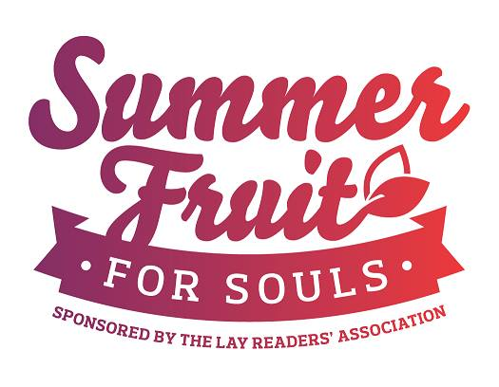

REGISTRATION FORM
Summer Fruit for Souls 2021

Please complete the information below and send by mail or electronically to the Registrar:
Alison Bentley, 127 Rainbow Lane, Maberly, ON, K0H 2B0 or alisonbentley@gmail.com

First Name(s): ____________________________ Family Name: _________________________
Address: _________________________________ City/Town: ___________________________
Postal Code: ______________________ Phone(s): ___________________________________
Email : ________________________________________________________________________
Parish: _______________________________ Diocese: _________________________________

Two payment methods for your $75 registration fee*:

eTransfer to the Registrar at alisonbentley@gmail.com. No need for passwords, direct deposit is already enabled.
Payment by cheque: Cheques should be made out to the Diocese of Ontario and noted as SFFS. Mail to the Registrar Alison Bentley at the address above.

If you have any questions please contact the Conference Coordinator, Mary Raddon at (613) 386-3931; email: mraddon@hotmail.com.

*Please note that the deadline for registrations to be received is July 10.

Participation Opportunities: please let us know if you would like to be involved.

Leading Morning/Evening Prayer (including homily) ______
Reading for Morning/Evening Prayer _______
Leading Prayers for Morning/Evening Prayer _______
Providing worship music/songs ______
Do you have any ideas for an evening activity? ________________________________________

*Registration fees on a per person basis; couples should register separately

